**PRACTICAL: 2**

**AIM:** Create an android application to calculate sum of two numbers and gives result in Toast Message.

**THEORY:**

An Android Toast is a small message displayed on the screen, similar to a tool tip or other similar popup notification. A Toast is displayed on top of the main content of an activity, and only remains visible for a short time period.

**CODE:**

|  |
| --- |
| **MainActivity.java**  package com.example.a17it008_practical2;  import androidx.appcompat.app.AppCompatActivity;  import android.os.Bundle;  import android.view.View;  import android.widget.EditText;  import android.widget.Toast;  public class MainActivity extends AppCompatActivity {  EditText n1;  EditText n2;  String value1;  String value2;  protected void onCreate(Bundle savedInstanceState) {  super.onCreate(savedInstanceState);  setContentView(R.layout.activity_main);  n1 = findViewById(R.id.n1);  n2 = findViewById(R.id.n2);  }  public void sum(View view)  {  value1 = n1.getText().toString();  value2= n2.getText().toString();  int finalValue1=Integer.parseInt(value1);  int finalValue2 = Integer.parseInt(value2);  int n=finalValue1+finalValue2;  Toast.makeText(getApplicationContext(),"SUM is : "+n,Toast.LENGTH_SHORT).show();  }  }  **activity_main.xml**  <?xml version="1.0" encoding="utf-8"?>  <androidx.constraintlayout.widget.ConstraintLayout  xmlns:android="http://schemas.android.com/apk/res/android"  xmlns:tools="http://schemas.android.com/tools"  xmlns:app="http://schemas.android.com/apk/res-auto"  android:layout_width="match_parent"  android:layout_height="match_parent"  tools:context=".MainActivity">  <TextView  android:id="@+id/textView"  android:layout_width="wrap_content"  android:layout_height="wrap_content"  android:layout_marginRight="200dp"  android:layout_marginBottom="450dp"  android:text="first number"  android:textSize="24sp"  android:textStyle="bold"  app:layout_constraintBottom_toBottomOf="parent"  app:layout_constraintLeft_toLeftOf="parent"  app:layout_constraintRight_toRightOf="parent"  app:layout_constraintTop_toTopOf="parent" />  <EditText  android:id="@+id/n1"  android:layout_width="150dp"  android:layout_height="40dp"  android:layout_marginStart="400dp"  android:layout_marginLeft="400dp"  android:layout_marginTop="100dp"  android:layout_marginEnd="261dp"  android:layout_marginRight="261dp"  android:inputType="number"  app:layout_constraintBottom_toTopOf="@+id/textView"  app:layout_constraintEnd_toEndOf="parent"  app:layout_constraintStart_toStartOf="parent"  app:layout_constraintTop_toTopOf="parent"  tools:ignore="MissingConstraints" />  <TextView  android:id="@+id/textView2"  android:layout_width="wrap_content"  android:layout_height="wrap_content"  android:layout_marginRight="200dp"  android:layout_marginBottom="200dp"  android:text="second number"  android:textSize="24sp"  android:textStyle="bold"  app:layout_constraintBottom_toBottomOf="parent"  app:layout_constraintLeft_toLeftOf="parent"  app:layout_constraintRight_toRightOf="parent"  app:layout_constraintTop_toTopOf="parent" />  <EditText  android:id="@+id/n2"  android:layout_width="150dp"  android:layout_height="40dp"  android:layout_marginStart="400dp"  android:layout_marginLeft="400dp"  android:layout_marginTop="400dp"  android:layout_marginEnd="261dp"  android:layout_marginRight="261dp"  android:inputType="number"  app:layout_constraintBottom_toTopOf="@+id/textView"  app:layout_constraintEnd_toEndOf="parent"  app:layout_constraintStart_toStartOf="parent"  app:layout_constraintTop_toTopOf="parent"  app:layout_constraintVertical_bias="0.501"  tools:ignore="MissingConstraints" />  <Button  android:id="@+id/b1"  android:layout_width="wrap_content"  android:layout_height="wrap_content"  android:layout_marginStart="152dp"  android:layout_marginLeft="152dp"  android:layout_marginTop="122dp"  android:layout_marginBottom="300dp"  android:text="SUM"  android:onClick="sum"  app:layout_constraintBottom_toBottomOf="parent"  app:layout_constraintStart_toStartOf="parent"  app:layout_constraintTop_toBottomOf="@+id/textView2" />  </androidx.constraintlayout.widget.ConstraintLayout>  **AndroidManifest.xml**  <?xml version="1.0" encoding="utf-8"?>  <manifest xmlns:android="http://schemas.android.com/apk/res/android"  package="com.example.practical_2">  <application  android:allowBackup="true"  android:icon="@mipmap/ic_launcher"  android:label="17it008_Practical2"  android:roundIcon="@mipmap/ic_launcher_round"  android:supportsRtl="true"  android:theme="@style/AppTheme">  <activity android:name=".MainActivity">  <intent-filter>  <action android:name="android.intent.action.MAIN" />  <category android:name="android.intent.category.LAUNCHER" />  </intent-filter>  </activity>  </application>  </manifest> |

**OUTPUT:**

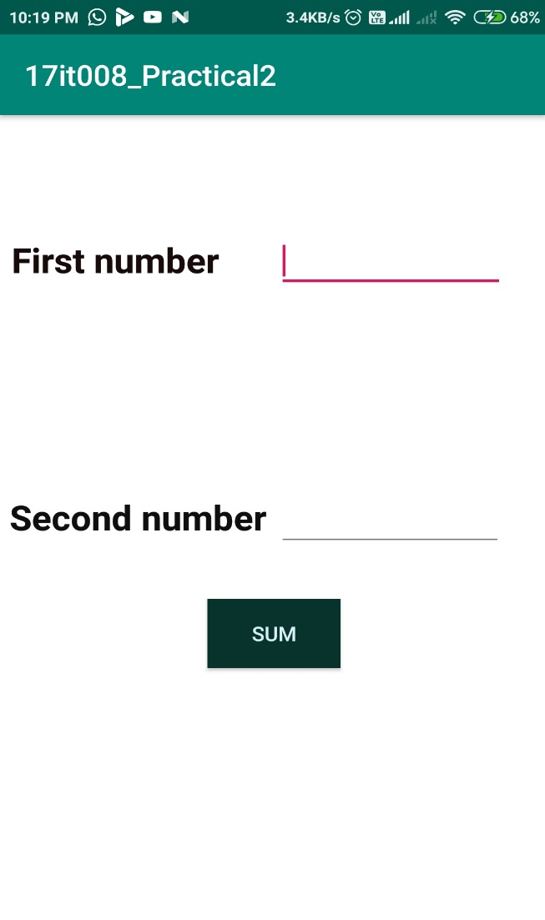

Main View Of app

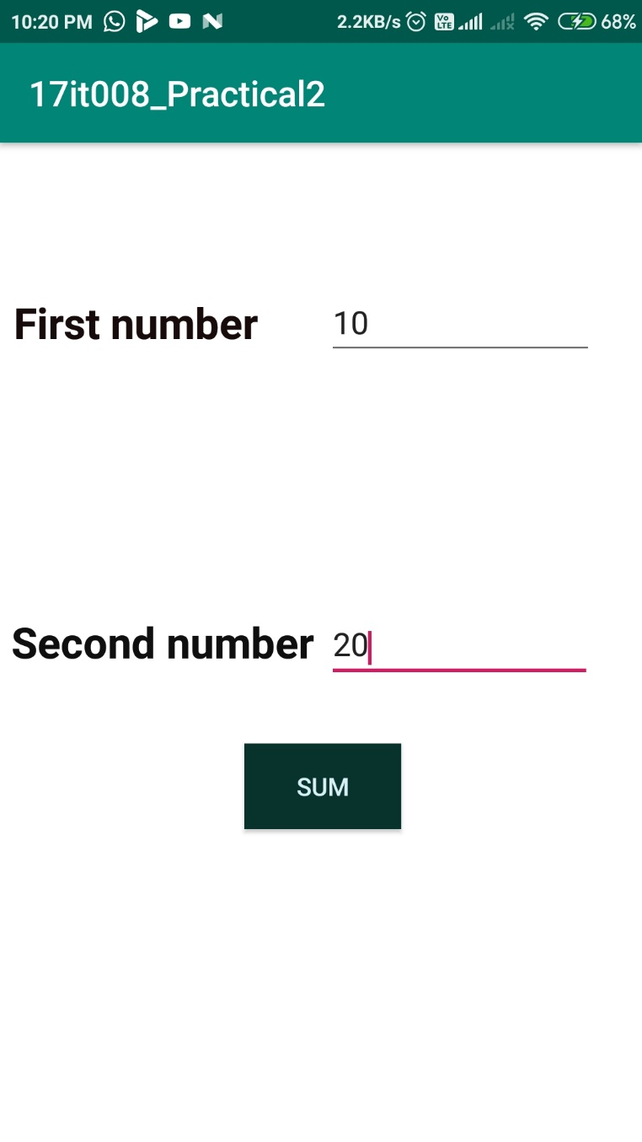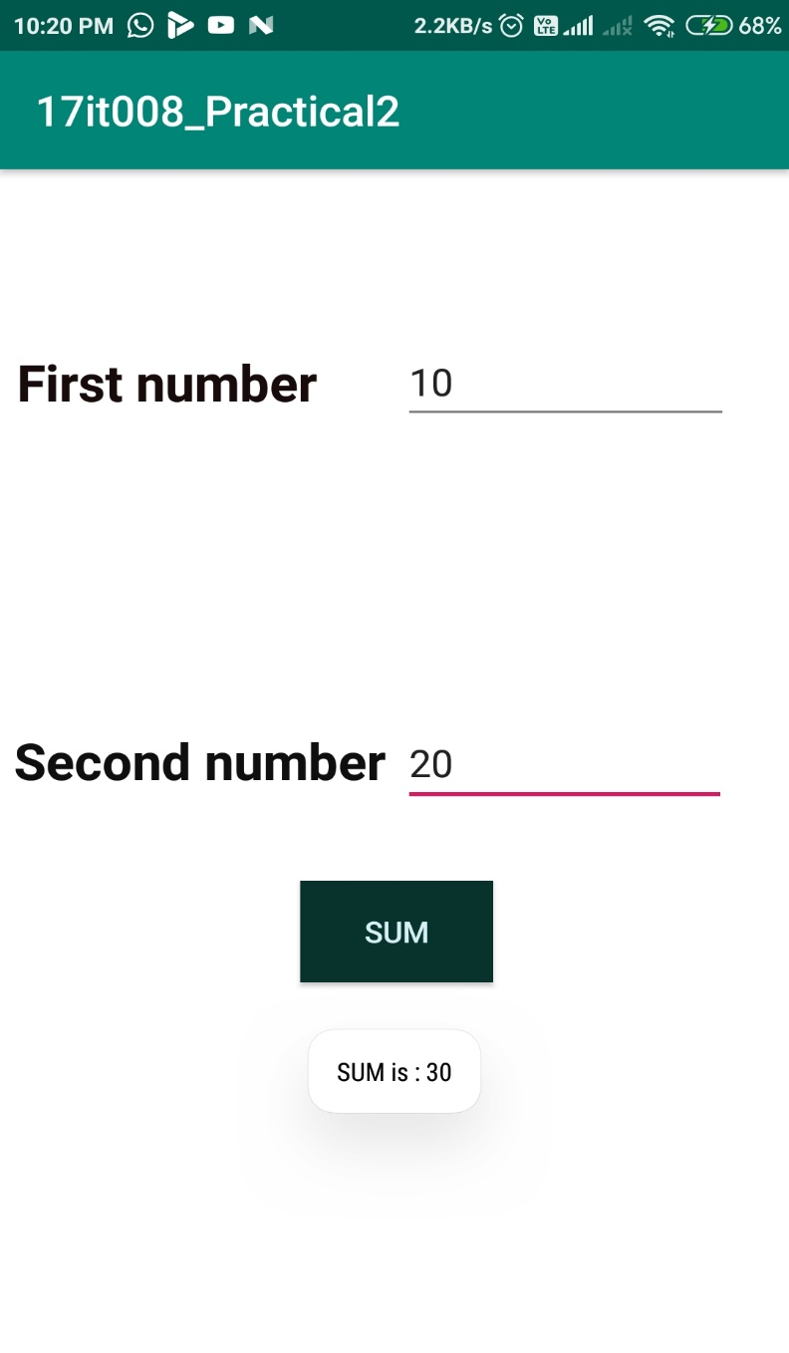

**Description**: When we enter two numbers in the Text Fields, it will simply sum that two integers and give the sum of that two number in Toast.

**LATEST APPLICATIONS:**

Android Studio, ADB (Android Debug Bridge), AVD Manager, Eclipse, Fabric, Genymotion,

**LEARNING OUTCOME:**

1.We learn how to make Toast message in android application and also We can make Android Application that will perform sum of two number and give sum in Toast Message.

2.We learned to set different items in constraint layout.